FOSTER FORWARD

TOOL  The Forward Focus  Snapshot | 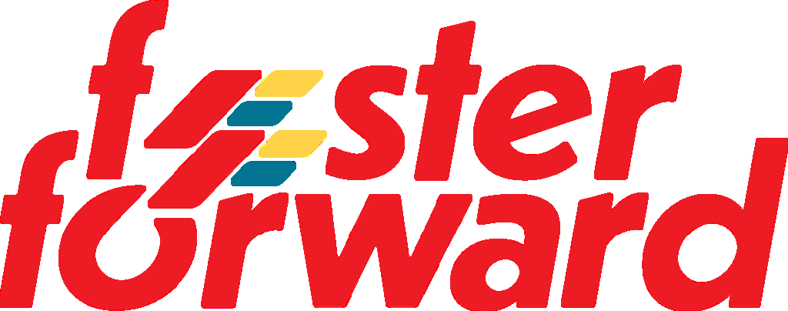

Pillar 3: Free Time Isn’t Free

WHAT'S INSIDE: For Parents who want to get past the one word answer: A daily habit that builds awareness and opens conversation

The Player's Playbook for Life · fosterforward.com

The Parent Problem:

"I ask my child what they did today. They say nothing. And the conversation ends."
- You want to get past the one word answer.
- You want to know what they're excited about.
- You want to know what's worrying them.
- You want to know what's really going on in their life.
- But you don't know how to open that door.
This tool gives you both something to look at together. A simple structure that turns "nothing" into a real conversation.

💡 Free time is where habits are built.
Most kids don't think about it. Most parents don't either.
But what your child does between school and bed — every day — is quietly shaping who they are becoming.
This tool makes that visible. For you and your child. Together.

WHEN TO USE THIS
Build it into the daily routine — just like homework.
Same time every day. Before bed works well.

"This is part of our routine now. Fill it in every day. Share what you want when you're done."
That's it. No negotiation. No agenda. Just the process — held consistently until it becomes a habit.

The one rule — let them share on their own terms. Your job is to hold the structure. Not to inspect the results.

The Tool:

Time Block | What I Did | How I Felt (1 word)
☀️  Morning | _______________________________________________ | ______________________
🏫  School | _______________________________________________ | ______________________
🎒  After School | _______________________________________________ | ______________________
🌙  Evening | _______________________________________________ | ______________________
🛏️  Before Bed | _______________________________________________ | ______________________

2 | What I Usually Do in My Free Time

Check all that apply.

☐ Scroll | ☐ Watch Videos
☐ Game | ☐ Text / Talk
☐ Read | ☐ Practice a Skill
☐ Clean / Organize | ☐ Rest
☐ Drift / "Nothing Really" | ☐ Other: ___________________

3 | How Each Choice Affects Me

For each activity you checked above, mark the column that best describes how you feel when doing it.

Activity | Builds Me | Drains Me | Distracts Me | Helps Me | Hurts Me
________________________________ | ☐ | ☐ | ☐ | ☐ | ☐
________________________________ | ☐ | ☐ | ☐ | ☐ | ☐
________________________________ | ☐ | ☐ | ☐ | ☐ | ☐

4 | One Small Habit I Want to Build + How I Want to Feel After

One Small Habit I Want to Build | How I Want to Feel After (circle one)
___________________________________________________ | Proud • Focused • Calm • Strong • Confident • Ready  Other: ___________________

REMEMBER THIS:

You don't get better because you want to. You get better because of what you do when you don't feel like it. Every single day. That's the habit. That's what this tool tracks.
— Marcus Foster, Foster Forward

HOW TO USE THIS TOOL

- Print a fresh copy each week. Use it as a Sunday reset or a Monday morning awareness check.
- Be honest — not perfect. This isn't a report card. It's a mirror. What you see is just information.
- Complete all four sections in order. Each one builds awareness from the last. Don't skip Section 4.
- Track your patterns over time. Use the Foster Forward Journal to compare weekly snapshots and watch your habits shift.

READY FOR THE FULL SYSTEM?
This tool is one piece of the Foster Forward system. The Player's Playbook for Life Journal brings all 7 tools together into your child's daily practice.

Get the Journal → fosterforward.com/journal

Foster Forward · The Player's Playbook for Life · Atlanta, GA · fosterforward.com

